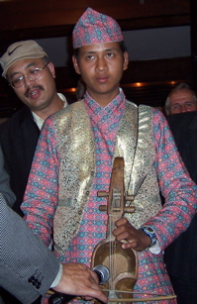
BREAKFAST CHATTER
Weekly Bulletin of Rotary Club of Kathmandu Mid-Town
District 3290 Volume No. 15/20 for #762 December 03, 2004
www.rotarymidtown.org.np
DECEMBER IS ELECTION OF NEW BOARD MONTH

SUNSHINE ANNOUNCEMENT FOR THE WEEK OF 03 DECEMBER 2004; Our birthday greetings Dec 7 to Kali Bahadur Rokaya; on December 11 to Sharada spouse of Komal Chitrakar, and to Rama spouse of Yogendra Pradhan; and for Yogendra Pradhan a double celebration: anniversary with Rama on the 7th and birthday on the 9th. *********** Kailash gets sarangi lesson>>>
*********** MEETING ACTIVITIES:
DATE | ACTIVITY | SUBJECT
3 DEC | Shyam Nepali | the best of Sarangi
10 DEC | Rabi Karmacharya | Software Outsourcing Prospects for Nepal
DEC or JAN | Health Camps | Naubise & Tistung with ADRA/Hartmut

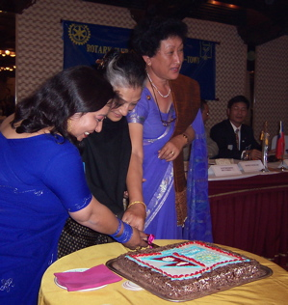
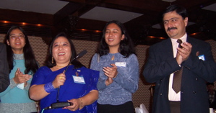
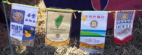


**************** NEWS:, The health camp and evening with our Taiwan colleagues was a big success. Hope you were there.
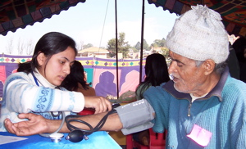
**************** THIS WEEK’S EVENT IS A PRESENTATION BY SHYAM NEPALI
A professional sarangi player, Shyam has agreed to share with us some of his music.
**************** Please join us!

YIR…David

